Name: Kanwalpreet Singh
Roll no. 2610997039
Experiment No. 1

Question1-2 Write the basic HTML5 document structure and implement all six heading tags (<h1> to <h6>) with sample text.
CODE:
<!DOCTYPE html>
<html lang="en">
<head>
<meta charset="UTF-8">
<title>26110997039</title>
</head>
<body>
<h1>html heading tag</h1>
<h2>html heading tag</h2>
<h3>html heading tag</h3>
<h4>html heading tag</h4>
<h5>html heading tag</h5>
<h6>html heading tag</h6>
</body>
</html>

OUTPUT:
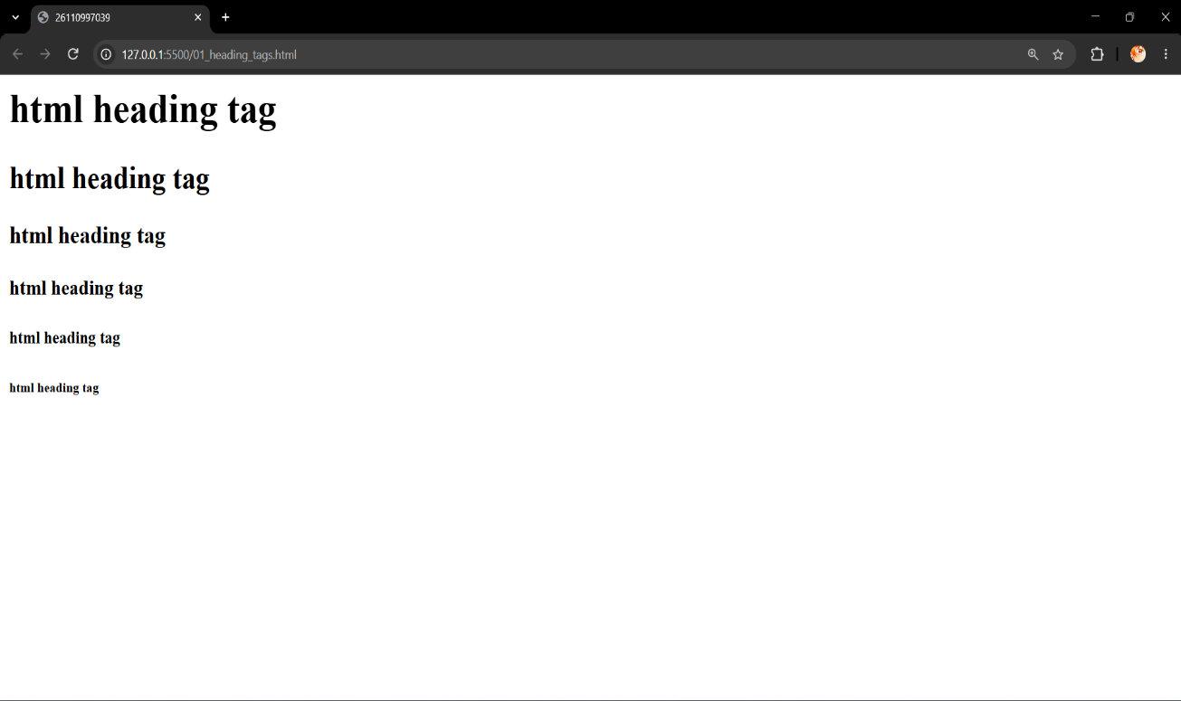

Name: Kanwalpreet Singh
Roll no. 2610997039
Experiment 2
Question 3-4: Create a paragraph and apply text formatting tags (<b>, <i>, <u>, <strong>, <em>) to given content
CODE:
<!DOCTYPE html>
<html lang="en">
<head>
<meta charset="UTF-8">
<title>2610997039</title>
</head>
<body>

<p style="text-align: center; font-size: 50px;">
<b>bold</b>
<i>italics</i> <u>underline</u>
<strong>strong text</strong> <em>emphasized text</em>.
</p>

</body>
</html>

OUTPUT:
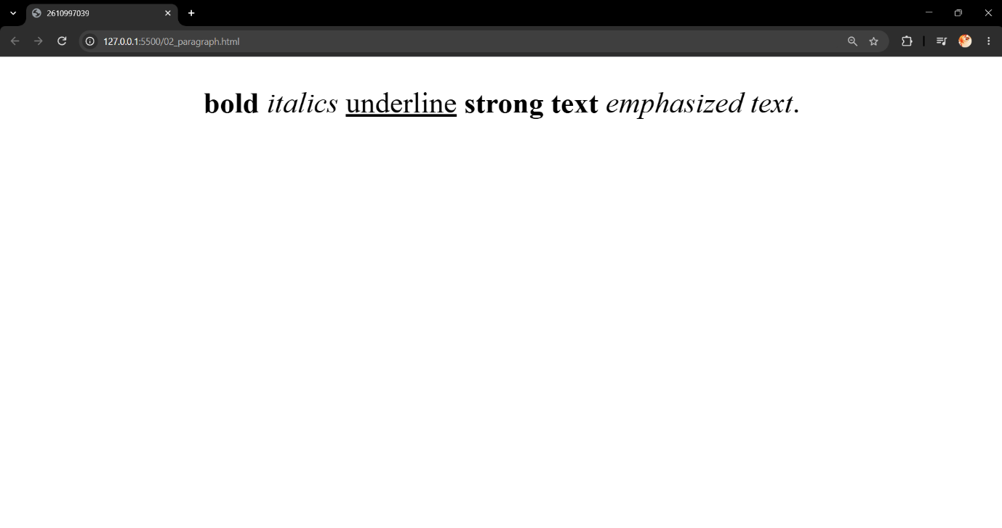

Name: Kanwalpreet Singh
Roll no. 2610997039
Experiment 3
Question 5-6 Create an ordered list (<ol>) for a recipe’s steps and an unordered list (<ul>) for its ingredients on the same page.
CODE:
<!DOCTYPE html>
<html lang="en">
<head>
<title>2610997039</title>
</head>
<body>

<h1>Simple Tea Recipe</h1>

<h2>Ingredients</h2>
<ul>
<li>1 cup water</li>
<li>1 cup milk</li>
<li>1 tea bag or tea leaves</li>
<li>Sugar to taste</li>
</ul>

<h2>Steps</h2>
<ol>
<li>Boil the water in a small pan.</li>
<li>Add the tea leaves or tea bag and let it simmer.</li>
<li>Pour in the milk and bring the mixture to a boil.</li>
<li>Add sugar to taste, strain into a cup, and serve hot.</li>
</ol>
</body>
</html>
OUTPUT:
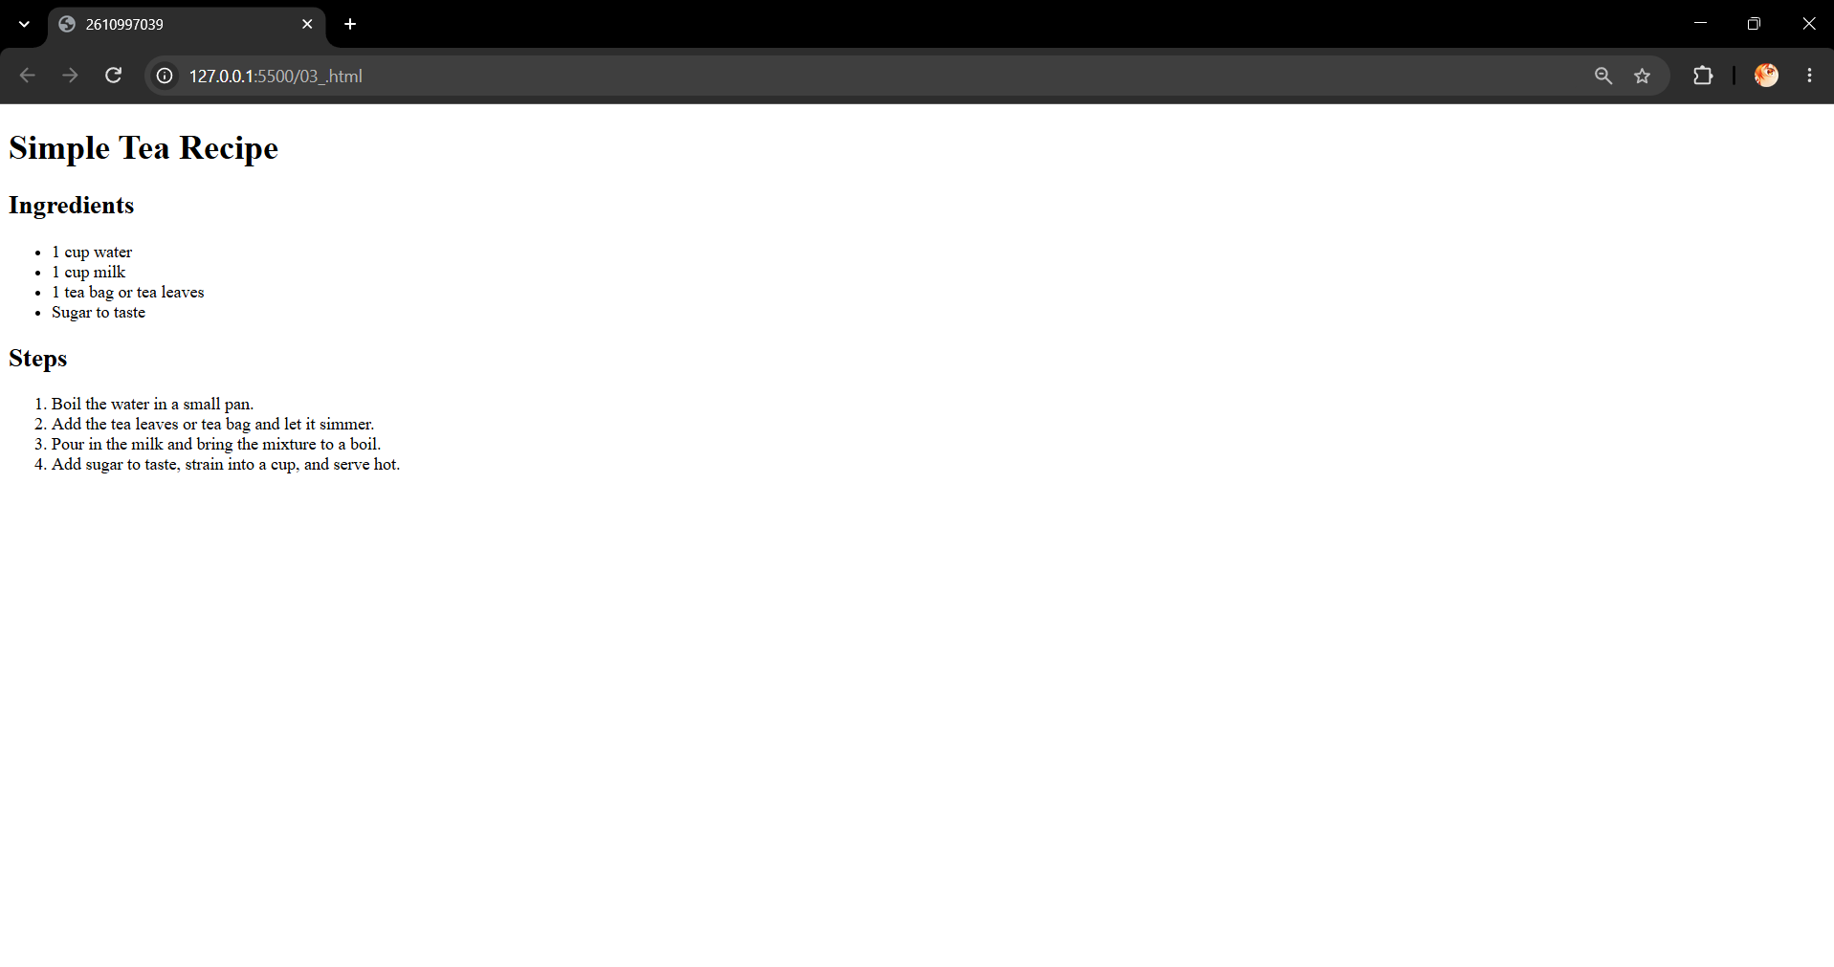

Name: Kanwalpreet Singh
Roll no. 2610997039
Experiment 4
Question 7-8 Build a nested list showing a hierarchy: Category Books Chapteres using <ul> and <ol> together.
CODE:
<!DOCTYPE html>
<html lang="en">
<head>
<title>2610997039</title>
</head>
<body>
<ul>
<li>Fiction & Literature
<ul>
<li>The Great Gatsby
<ol>
<li>Chapter 1: West Egg Arrival</li>
<li>Chapter 2: The Valley of Ashes</li>
<li>Chapter 3: Gatsby's Party</li>
</ol>
</li>
</ul>
</li>
</ul>
</body>
</html>

OUTPUT:
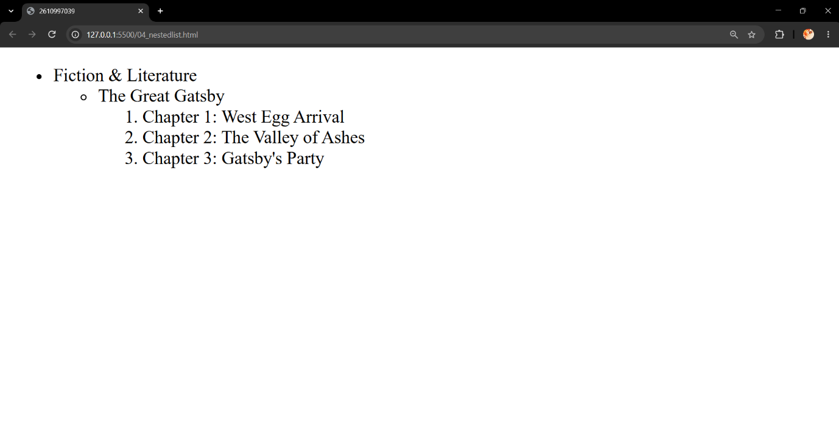

Name: Kanwalpreet Singh
Roll no. 2610997039
Experiment 4
Question 9-10 Insert an image using <img> and set src, alt, width, height, and title attributes with valid paths.
CODE:
<!DOCTYPE html>
<html lang="en">
<head>
<title>2610997039</title>
</head>
<body>
<div class="image-container">
<img src="/img/615-600x400.jpg"
alt="Ocean"
width="600"
height="400"
title="Ocean">
<p>Hover over the image to see the <code>title</code> tooltip.</p>
</div>
</body>
</html>

OUTPUT:
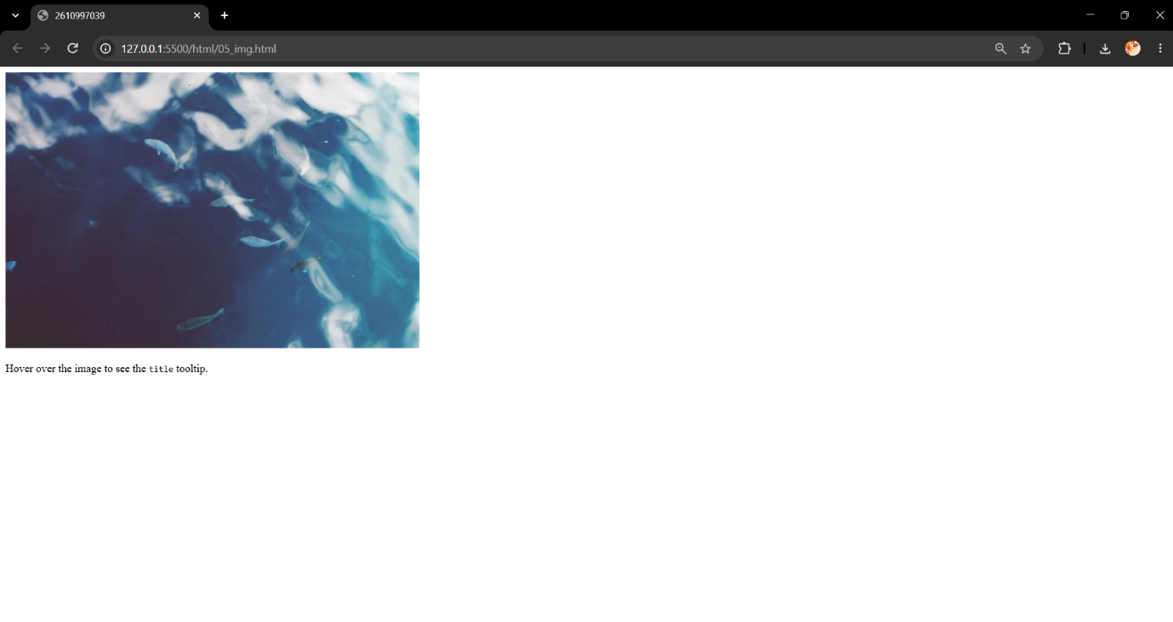

Name: Kanwalpreet Singh
Roll no. 2610997039
Experiment 5
Question 11-12 Set a background image for the entire webpage within the <body> tag.
CODE:
<!DOCTYPE html>
<html>
<head>
<title>2610997039</title>
</head>
<body background="your-image-url.jpg">

<h1>Welcome to My Webpage!</h1>

</body>
</html>

OUTPUT:
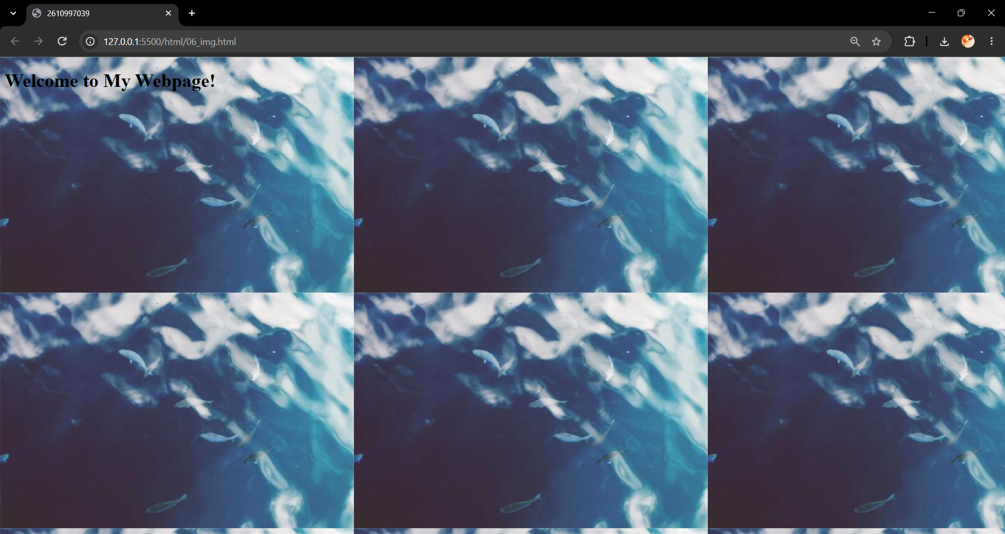

Name: Kanwalpreet Singh
Roll no. 2610997039
Experiment 6
Question 13-14 Create internal anchor links that jump to sections on the same page and one external to a university website.
CODE:
<!DOCTYPE html>
<html lang="en">
<head>
<title>2610997039</title>
</head>
<body>

<nav>
<ol>
<li><a href="#section1">Jump to Section 1</a></li>
<li><a href="#section2">Jump to Section 2</a></li>
<li><a href="https://www.chitkara.edu.in/" target="_blank">Chitkara University</a></li>
</ol>
</nav>

<section id="section1">
<h2>Section 1</h2>
<p>This is the first section of the page. Clicking the internal anchor link brings you here.</p>
</section>

<br><br><br><br><br><br><br><br><br><br><br><br><br><br><br><br><br><br><br><br><br><br><br><br><br><br><br><br><br><br><br><br><br><br><br><br><br><br><br><br><br><br><br><br><br><br><br><br><br><br><br><br><br><br><br><br><br><br><br><br><br><br><br><br><br><br><br><br><br><br><br><br><br><br><br><br><br><br><br><br><br><br><br><br><br><br><br><br><br><br><br><br><br><br><br><br><br><br><br><br><br><br><br><br><br><br><br><br><br><br><br><br><br><br><br><br><br><br><br><br><br><br><br><br><br><br><br><br><br><br><br><br><br><br><br><br><br><br><br><br><br><br><br><br><br><br><br><br><br><br><br><br><br><br><br><br><br><br><br<br><br><br><br><br><br><br><br><br><br><br><br><br><br><br><br><br><br><br><br><br><br><br><br><br><br><br><br><br><br><br><br><br><br><br><br><br><br><br><br><br>

<section id="section2">
<h2>Section 2</h2>
<p>This is the second section of the page. Clicking the second internal anchor link brings you here.</p>
</section>

</body>
</html>
OUTPUT:
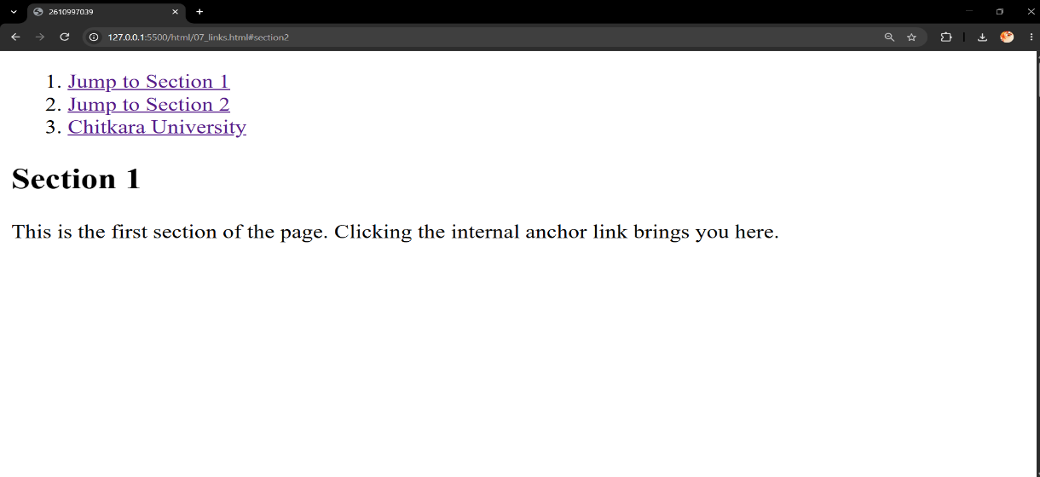
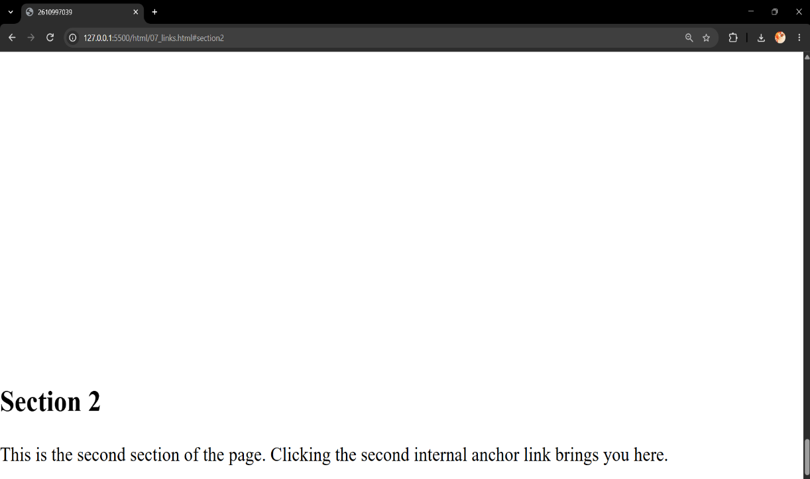
Name: Kanwalpreet Singh
Roll no. 2610997039
Experiment 7
Question 15-16 Design an image map with clickable regions.
CODE:
<html lang="en">
<head>
<title>2610997039</title>
</head>
<body>
<h1>Map of India</h1>
<center><img src="img/India-Map-States-Colored.jpg" alt="Indiamap" usemap="#Indiamap"></center>

<map name="Indiamap">
<area shape="rect" coords="146, 50, 200, 94" href="https://en.wikipedia.org/wiki/Jammu_and_Kashmir_(union_territory)" alt="Jammu and Kashmir" target="_blank" title="Jammu and Kashmir">

<area shape="rect" coords="178, 123, 197, 145" href="https://en.wikipedia.org/wiki/Himachal_Pradesh" alt="Himachal Pradesh" target="_blank" title="Himachal Pradesh">

<area shape="rect" coords="145, 141, 165, 171" href="https://en.wikipedia.org/wiki/Punjab,_India" alt="Punjab" target="_blank" title="Punjab">

<area shape="rect" coords="212, 155, 233, 185" href="https://en.wikipedia.org/wiki/Uttarakhand" alt="Uttarakhand" target="_blank" title="Uttarakhand">

<area shape="rect" coords="158, 188, 175, 208" href="https://en.wikipedia.org/wiki/Haryana" alt="Haryana" target="_blank" title="Haryana">

<area shape="rect" coords="220, 207, 290, 275" href="https://en.wikipedia.org/wiki/Uttar_Pradesh" alt="UttarPradesh" target="_blank" title="Uttar Pradesh">

<area shape="circle" coords="120, 248, 60" href="https://en.wikipedia.org/wiki/Rajasthan" alt="Rajasthan" target="_blank" title="Rajasthan">

<area shape="poly" coords="325, 235, 339, 269, 321, 287, 384, 284, 392, 258,325, 235" href="https://en.wikipedia.org/wiki/Bhar" alt="Bhar" target="_blank" title="Bhar">
</map>

</body>
</html>
OUTPUT:
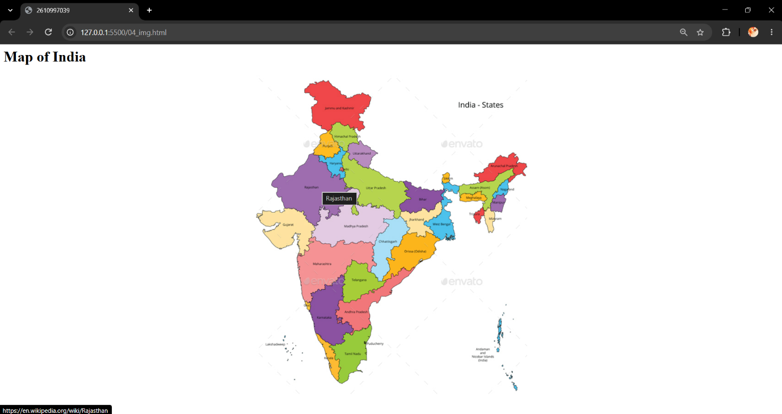

Name: Kanwalpreet Singh
Roll no. 2610997039
Experiment 8
Question 17-18 Build a student mark sheet table.
CODE:
<html lang="en">
<head>
<meta charset="UTF-8">
<title>2610997039</title>
</head>
<body>
<table cellspacing="7px" cellpadding="7px" border="2px">
<tr bgcolor="yellow">
<th rowspan="2">Sr.no.</th>
<th rowspan="2">Roll no.</th>
<th rowspan="2">Name</th>
<th colspan="5">Subjects</th>
<th rowspan="2">Address</th>
</tr>
<tr bgcolor="yellow">
<td>English</td>
<td>Mathematics</td>
<td>Science</td>
<td>History</td>
<td>Computer Science</td>
</tr>

<tr bgcolor="grey">
<td>1</td>
<td>01</td>
<td>Anderson</td>
<td align="center">85</td>
<td align="center">90</td>
<td align="center">88</td>
<td align="center">76</td>
<td align="center">95</td>
<td>randomaddress</td>
</tr>
<tr bgcolor="Purple">
<td>2</td>
<td>02</td>
<td>Bennett</td>
<td align="center">85</td>
<td align="center">90</td>
<td align="center">88</td>
<td align="center">76</td>
<td align="center">95</td>
<td>randomaddress</td>
</tr>
<tr bgcolor="grey">
<td>3</td>
<td>03</td>
<td>Carter</td>
<td align="center">85</td>
<td align="center">90</td>
<td align="center">88</td>
<td align="center">76</td>
<td align="center">95</td>
<td>randomaddress</td>
</tr>
<tr bgcolor="Purple">
<td>4</td>
<td>04</td>
<td>Davis</td>
<td align="center">85</td>
<td align="center">90</td>
<td align="center">88</td>
<td align="center">76</td>
<td align="center">95</td>
<td>randomaddress</td>
</tr>
<tr bgcolor="grey">
<td>5</td>
<td>05</td>
<td>Edwards</td>
<td align="center">85</td>
<td align="center">90</td>
<td align="center">88</td>
<td align="center">76</td>
<td align="center">95</td>
<td>randomaddress</td>
</tr>
<tr bgcolor="Purple">
<td>6</td>
<td>06</td>
<td>Harris</td>
<td align="center">85</td>
<td align="center">90</td>
<td align="center">88</td>
<td align="center">76</td>
<td align="center">95</td>
<td>randomaddress</td>
</tr>
</table>
</body>
</html>
OUTPUT:
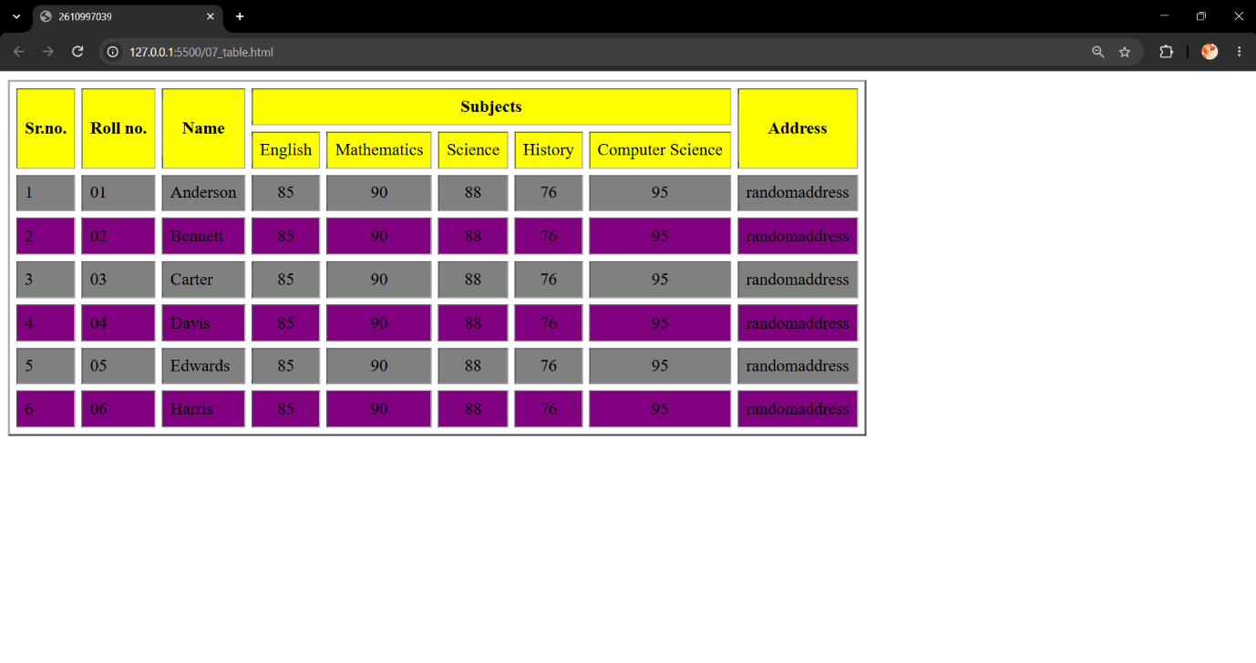

Name: Kanwalpreet Singh
Roll no. 2610997039
Experiment 9
Question 19-20 create a nested timetable table.
CODE:
<!DOCTYPE html>
<html>
<head>
<title>2610997039</title>
</head>
<body>

<table border="1" cellpadding="8" cellspacing="0" align="center">
<caption><strong>Weekly Master Timetable (Nested View)</strong></caption>
<thead>
<tr>
<th>Day</th>
<th>Session</th>
<th>Time Slot</th>
<th>Grade 9-A</th>
<th>Grade 9-B</th>
</tr>
</thead>
<tbody>
<tr>
<td rowspan="7"><strong>Monday</strong></td>
<td rowspan="2"><strong>Morning</strong></td>
<td>08:30 - 09:15</td>
<td>Mathematics</td>
<td>Physics</td>
</tr>
<tr>
<td>09:15 - 10:00</td>
<td>English</td>
<td>Chemistry</td>
</tr>
<tr>
<td><em>Break</em></td>
<td>10:00 - 10:30</td>
<td colspan="2" align="center"><em>Morning Recess</em></td>
</tr>
<tr>
<td rowspan="4"><strong>Afternoon</strong></td>
<td>10:30 - 11:15</td>
<td>Physics</td>
<td>Mathematics</td>
</tr>
<tr>
<td>11:15 - 12:00</td>
<td>History</td>
<td>Geography</td>
</tr>
<tr>
<td>12:00 - 01:00</td>
<td colspan="2" align="center"><em>Lunch Break</em></td>
</tr>
<tr>
<td>01:00 - 01:45</td>
<td>Computer Science</td>
<td>Art & Craft</td>
</tr>

<tr>
<td rowspan="7"><strong>Tuesday</strong></td>
<td rowspan="2"><strong>Morning</strong></td>
<td>08:30 - 09:15</td>
<td>Chemistry</td>
<td>Mathematics</td>
</tr>
<tr>
<td>09:15 - 10:00</td>
<td>Mathematics</td>
<td>English</td>
</tr>
<tr>
<td><em>Break</em></td>
<td>10:00 - 10:30</td>
<td colspan="2" align="center"><em>Morning Recess</em></td>
</tr>
<tr>
<td rowspan="4"><strong>Afternoon</strong></td>
<td>10:30 - 11:15</td>
<td>English</td>
<td>Physics</td>
</tr>
<tr>
<td>11:15 - 12:00</td>
<td>Geography</td>
<td>History</td>
</tr>
<tr>
<td>12:00 - 01:00</td>
<td colspan="2" align="center"><em>Lunch Break</em></td>
</tr>
<tr>
<td>01:00 - 01:45</td>
<td>Physical Education</td>
<td>Computer Science</td>
</tr>
</tbody>
</table>

</body>
</html>
OUTPUT:
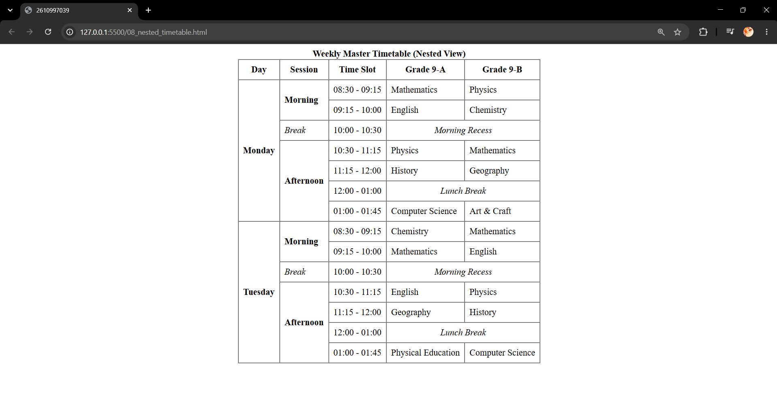

Name: Kanwalpreet Singh
Roll no. 2610997039
Experiment 10
Question 21-22 Design a table using twospan and colspan.
CODE:
<!DOCTYPE html>
<html>
<head>
<title>2610997039</title>
</head>
<body>
<table border="4px" cellpadding="10px" cellspacing="6px" align="center">
<tr align="center">
<td>1</td>
<td>2</td>
<td>3</td>
<td>4</td>
</tr>
<tr align="center">
<td>5 <br> Row-2</td>
<td>6 <br> Row-2</td>
<td rowspan="2">
11-Table-3
<table border="2px" align="center">
<tr>
<td>13</td>
<td>14</td>
</tr>
<tr>
<td>15</td>
<td>16</td>
</tr>
<tr align="center">
<td colspan="2">17</td>
</tr>
</table>
</td>
<td>12</td>
</tr>
<tr>
<td colspan="2" align="center">
7(Row-3)
<table border="2px" align="center">
<tr align="center">
<td colspan="2">8-Table-2</td>
</tr>
<tr align="center">
<td>9</td>
<td>10</td>
</tr>
</table>
</td>
<td align="center">18 <br> Row-4</td>
</tr>
</table>
</body>
</html>

OUTPUT:
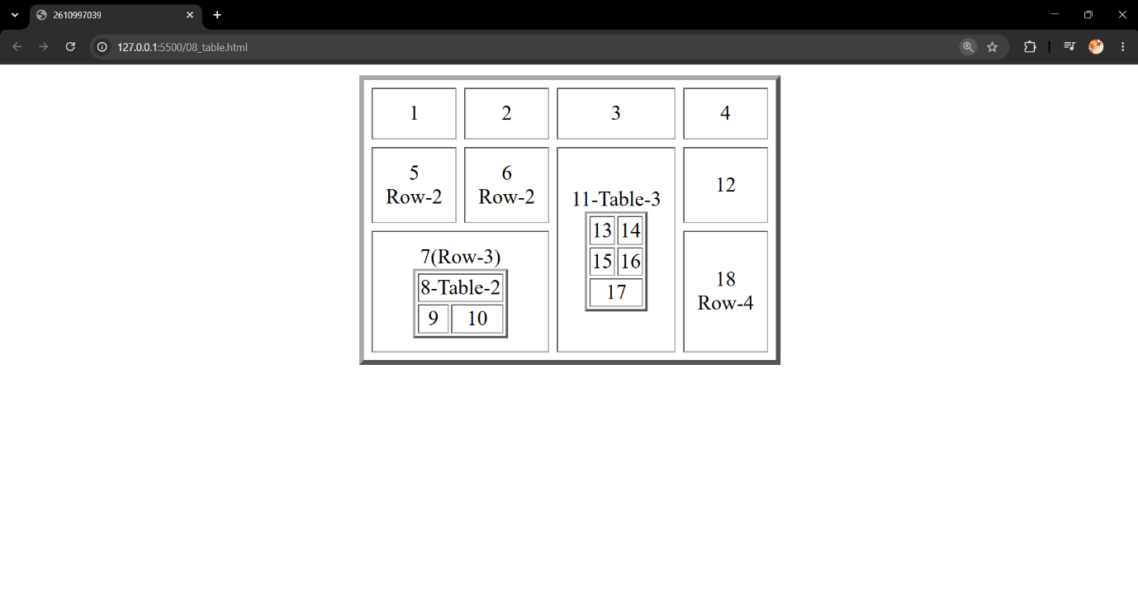

Name: Kanwalpreet Singh
Roll no. 2610997039
Experiment 11
Question 23-24 Build a registration form using GET method.
CODE:
<!DOCTYPE html>
<html lang="en">
<head>
<title>2610997039</title>
</head>
<body bgcolor="pink">

<fieldset>
<legend align="center" ><h2>STUDENT REGISTRATION FORMS</h2></legend>

<form method="get">
<table align="center" cellpadding="10px">
<tr>
<td><label for="firstName">FIRST NAME</label></td>
<td><input type="text" maxlength="30" name="firstName" id="firstName" required>(max 30 charcters a-z and A-Z)</td>
</tr>
<tr>
<td><label for="email">EMAIL ID</label></td>
<td><input type="email" name="email" id="email" placeholder="randomeamil.com" required></td>
</tr>
<tr>
<td><label for="phoneNumber">PHONE NUMBER</label></td>
<td><input type="tel" name="phoneNumber" id="phoneNumber" placeholder="000-000-0000" required></td>
</tr>
<tr>
<td><label for="gender">GENDER</label></td>
<td>
<input type="radio" name="gender" id="male"><label for="male">Male</label>
<input type="radio" name="gender" id="female"><label for="female">Female</label>
<input type="radio" name="gender" id="non_Binary"><label for="non_Binary">Non-binary</label>
<input type="radio" name="gender" id="pnts"><label for="pnts">Prefer not to say</label>
</td>
</tr>
<tr rowspan="4">
<td><label for="address">ADDRESS</label></td>
<td colspan="30">
<textarea name="address" id="address" placeholder="Enter your full address" required></textarea></td>
</tr>
<tr>
<td><label for="city">CITY</label></td>
<td><input type="text" name="city" id="city" placeholder="Enter City" required></td>
</tr>
<tr>
<td><label for="pinCode">PIN CODE</label></td>
<td><input type="text" name="pinCode" id="pinCode" maxlength="6" placeholder="Enter 6-digit pin" required></td>
</tr>
<tr>
<td><label for="state">STATE</label></td>
<td><input type="text" name="state" id="state" placeholder="Enter state" required></td>
</tr>
<tr>
<td><label for="country">COUNTRY</label></td>
<td><input type="text" name="country" id="country" placeholder="Enter country" required></td>
</tr>
<tr>
<td><label for="hobbies">HOBBIES</label></td>
<td colspan="4">
<input type="checkbox" name="drawing" id="drawing"><label for="drawing">Drawing</label>
<input type="checkbox" name="singing" id="singing"><label for="singing">Singing</label>
<input type="checkbox" name="dancing" id="dancing"><label for="dancing">Dancing</label>
<input type="checkbox" name="sketching" id="sketching"><label for="sketching">Sketching</label>
Others <input type="text" name="otherHobbies">
</td>
</tr>
<tr>
<td><label for="qualification">QUALIFICATION</label></td>
<td>
<table>
<tr>
<th align="center">SI.NO.Examinatin</th>
<th align="center">Board</th>
<th align="center">Percentage</th>
<th align="center">Year of Passing</th>
</tr>
<tr>
<td>1. Class X</td>
<td><input type="text" required></td>
<td><input type="text" required></td>
<td><input type="text" required></td>
</tr>
<tr>
<td>2. Class XII</td>
<td><input type="text" required></td>
<td><input type="text" required></td>
<td><input type="text" required></td>
</tr>
<tr>
<td>3. Graduation</td>
<td><input type="text" required></td>
<td><input type="text" required></td>
<td><input type="text" required></td>
</tr>
<tr>
<td>4. Masters</td>
<td><input type="text" required></td>
<td><input type="text" required></td>
<td><input type="text" required></td>
</tr>
<tr>
<td></td>
<td align="center">(10 charcters max)</td>
<td align="center">(Upto 2 Decimal)</td>
</tr>
</table>
</td>
</tr>
<tr>
<td><label for="couresApplied">COURE APPLIED FOR</label></td>
<td>
BCA<input type="radio" name="couresApplied" id="bca">
B.Com<input type="radio" name="couresApplied" id="bcom">
B.Sc<input type="radio" name="couresApplied" id="bsc">
B.A<input type="radio" name="couresApplied" id="ba">
</td>
</tr>
<tr>
<td></td>
<td>
<input type="submit" value="submit">
<input type="reset" value="reset">
</td>
</tr>
</table>
</form>
</fieldset>
</body>
</html>
OUTPUT:
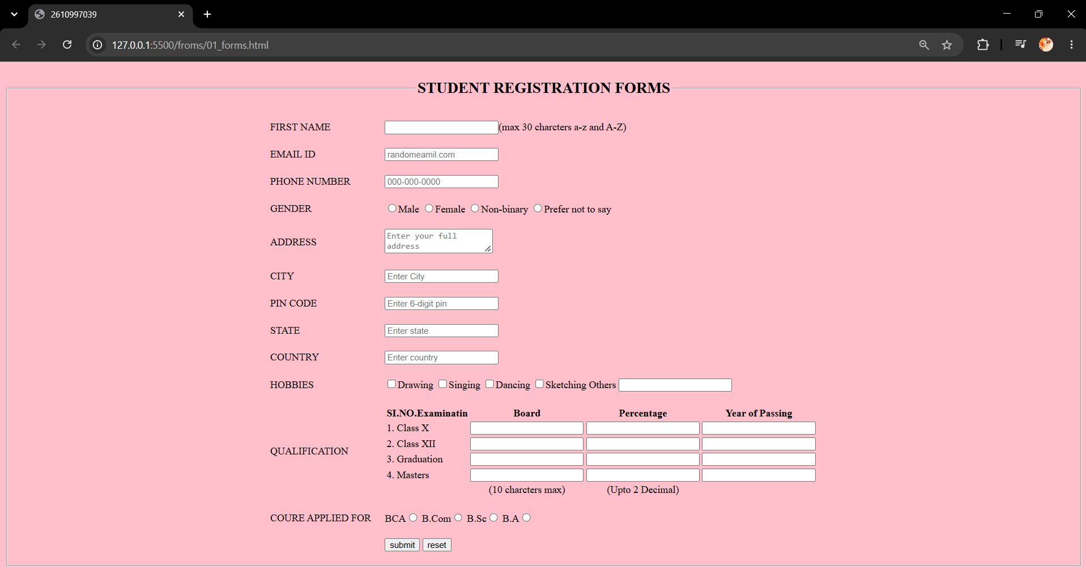

Name: Kanwalpreet Singh
Roll no. 2610997039
Experiment 12
Question Build a feedback form using POST method.
CODE:
<!DOCTYPE html>
<html>
<head>
<title>2610997039</title>
</head>
<body bgcolor="yellow">
<fieldset>
<legend align="center"><h2><font color="red">HP Agency Feedback Form</font></h2></legend>
<form method="post">
<table align="center" cellpadding="8">
<tr>
<td>
<label for="name">NAME:</label>
</td>
<td>
<input type="text" name="name" id="name">
</td>
</tr>
<tr>
<td>
<label for="email">EMAIL:</label>
</td>
<td>
<input type="email" name="email" id="email">
</td>
</tr>
<tr>
<td><label for="address">ADDRESS:</label></td>
<td>
<textarea name="address" id="address" placeholder="Enter your full address" rows="3" cols="25" required></textarea>
</td>
</tr>
<tr>
<td><label for="postCode">POSTCODE:</label></td>
<td>
<input type="number" name="postCode" id="postCode">
</td>
</tr>
<tr>
<td colspan="2">
<table border="2" width="100%" cellpadding="5" cellspacing="0">
<tr>
<th>Product</th>
<th>Product Image</th>
<th>Quantity</th>
<th>Unit Price</th>
<th>Subtotal</th>
</tr>
<tr>
<td>HP SPECTRE</td>
<td><img src="/img/spector.jpg" alt="HP Spectre" height="25" width="25"></td>
<td><progress value="70" max="100">70%</progress></td>
<td>$31,000</td>
<td><input type="text" size="8"></td>
</tr>
<tr>
<td>HP SPECTRE</td>
<td><img src="/img/spector.jpg" alt="HP Spectre" height="25" width="25"></td>
<td><progress value="70" max="100">70%</progress></td>
<td>$31,000</td>
<td><input type="text" size="8"></td>
</tr>
<tr>
<td>HP SPECTRE</td>
<td><img src="/img/spector.jpg" alt="HP Spectre" height="25" width="25"></td>
<td><progress value="70" max="100">70%</progress></td>
<td>$31,000</td>
<td><input type="text" size="8"></td>
</tr>
<tr>
<td>HP SPECTRE</td>
<td><img src="/img/spector.jpg" alt="HP Spectre" height="25" width="25"></td>
<td><progress value="70" max="100">70%</progress></td>
<td>$31,000</td>
<td><input type="text" size="8"></td>
</tr>
<tr>
<td colspan="3"></td>
<td align="right"><b>Total:</b></td>
<td><input type="text" size="8"></td>
</tr>
</table>
</td>
</tr>
<tr>
<td colspan="2">
<strong>Credit Card Details</strong><br>
<em>Card Type:</em>
</td>
</tr>
<tr>
<td colspan="2">
<input type="radio" name="cards" id="visa"> <label for="visa">Visa</label><br>
<input type="radio" name="cards" id="mastercard"> <label for="mastercard">Mastercard</label><br>
<input type="radio" name="cards" id="amex"> <label for="amex">American Express</label><br>
<input type="radio" name="cards" id="diners"> <label for="diners">Diners Club</label>
</td>
</tr>
<tr>
<td><label for="cardNumber">Card Number:</label></td>
<td><input type="text" name="cardNumber" id="cardNumber"></td>
</tr>
<tr>
<td><label for="expiry">Expiry Date:</label></td>
<td><input type="text" name="expiry" id="expiry" placeholder="MM/YY"></td>
</tr>
<tr>
<td><label for="deliveryAddress">Delivery Address:</label></td>
<td>
<textarea name="deliveryAddress" id="deliveryAddress" rows="4" cols="25"></textarea>
</td>
</tr>
<tr>
<td colspan="2" align="center">
<input type="submit" value="Submit Form">
</td>
</tr>
</table>
</form>
</fieldset>
</body>
</html>
OUTPUT:
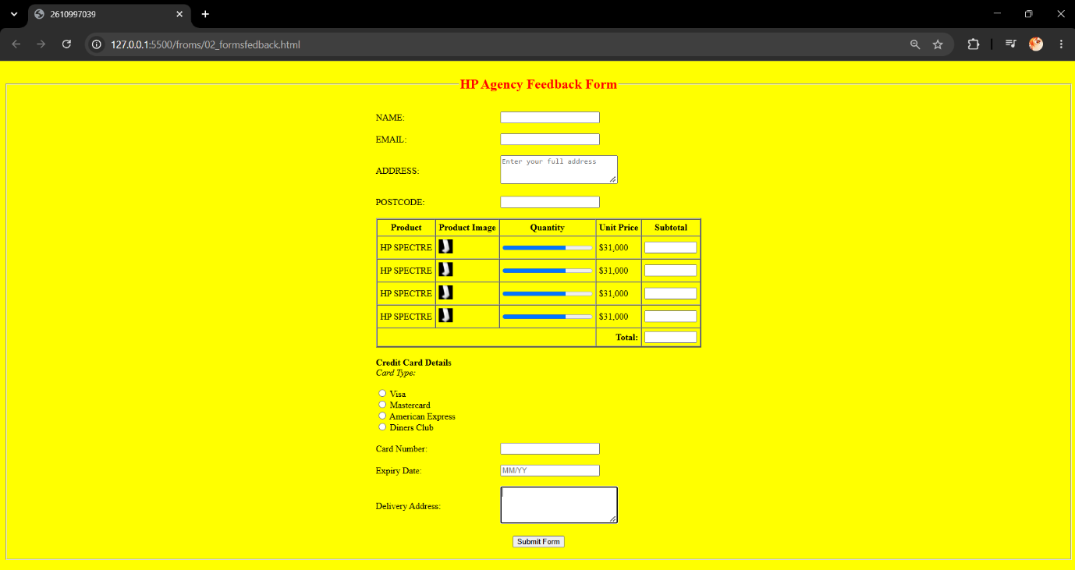

Name: Kanwalpreet Singh
Roll no. 2610997039
Experiment 13
Question Compare GET and POST forms.
Feature | GET Method | POST Method
Data Visibility | Visible: Data is appended directly to the URL as query parameters. | Hidden: Data is sent securely inside the request body.
Security | Low: Unsuitable for sensitive data (passwords, addresses, card details). | High: Secure and standard for personal or financial data.
Data Length Limit | Limited: Restricted by maximum URL length (approx. 2,048 characters). | Unlimited / Large: Can handle large text blocks and file uploads.
Bookmarkable | Yes: State is saved in the URL, making it easy to bookmark. | No: Cannot bookmark a POST request URL directly.
Caching | Cacheable: Responses can be cached by the browser for speed. | Not Cached: Every request is treated as a fresh submission.
Common Use Cases | Search bars, filters, and retrieving public web pages. | Registration forms, login pages, and checkout/payment forms.

Name: Kanwalpreet Singh
Roll no. 2610997039
Experiment 14
Question Create a frameset with navigation and content frames.
CODE:
<html>
<head>
<title>2610997039</title>
</head>
<frameset rows = "50%, 50%">
<frameset cols = "50%, 50%">
<frame src = "/04_img.html">
<frame src = "/froms/01_forms.html">
</frameset>
<frameset cols = "50%, 50%">
<frame src = "/07_table.html">
<frame src = "/06_tables3.html">
</frameset>
</frameset>
</html>
OUTPUT:
